A. The human nervous system
1. Joanna eats a toxic waste sweet, she feels a tingling in her mouth and her salivary glands release saliva. This is an example of a reflex action. Toxic waste sweets are covered in citric acid.
a. Describe the pathway of the reflex action and explain why her body reacted that way. (4)
b. Explain why reflex actions do not involve the conscious part of the brain. (2)
2. Scientists investigated the effects of caffeine and alcohol on people’s reaction times.

Their results are shown in the graph.

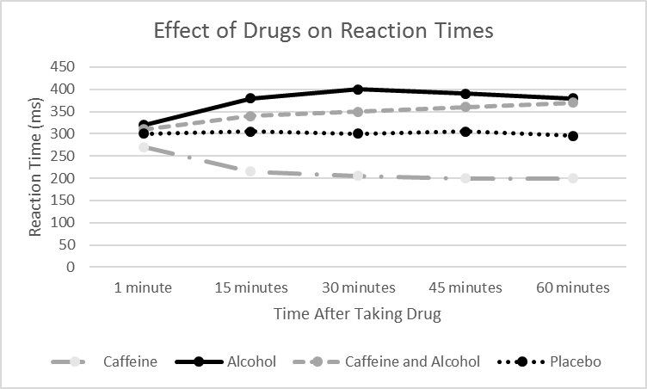

Use the data in the graph to compare the effect of the different drugs on reaction times. (4)

3. The diagram below shows the structure of the brain. (3)
- Name the structures A, B and C.
- Describe and explain the function of each of the structures in part a. (3)

4. Extended response question:
Neuroscientists have been able to map the regions of the brain to particular functions by studying patients with brain damage.
Describe and explain the methods they use to do this. (6)
5. Two common defects of the eyes are myopia (short sightedness) and hyperopia (long sightedness). Both defects mean that rays of light do not focus on the retina.
Explain why people cannot see clearly with each of these defects.
You should use diagrams to explain each defect. (6)
B. Cell differentiation
1. Eukaryotic cells can undergo differentiation. What does the term differentiation mean?
(2)
2. Explain how animal stem cells are different from plant stem cells. (3)
C. Cell division
1. Describe the relationship between the cell, genes, DNA and chromosomes.
You may draw a diagram if you wish. (3)

2. Explain why mitosis is important for multi-cellular organisms. (3)
3. Discuss the advantages and disadvantages of the use of plant stem cells. (4)

4. The chart below shows public attitudes towards stem cell research using human embryos.

a. Describe the trend for ‘in favour’ and ‘strongly in favour’ between 2001 and 2010. (3)
b. Calculate the percentage decrease for ‘strongly opposed’ at its highest and lowest points. (3)
c. Explain why some people may strongly oppose the use of human embryos in research. (4)

